**Brooklyn torah gazette**

**For parshas terumah 5781**

Volume 5, Issue 25 (Whole Number 225) 8 Adar 5781/ February 20, 2021

**Printed L’illuy nishmas Nechama bas R’ Noach, a”h**

For a free subscription, please forward your request to [***keren18@juno.com***](mailto:keren18@juno.com)

Past emails can be found on the website **ShabbosStories.com**

# Rav Avigdor Miller

# On Adar Happiness



**QUESTION: It says that in the month of Adar we have to be marbim b’simcha. How does one acquire more happiness during this month?**

**ANSWER:** And the answer is that you have to know that Hakodosh Boruch Hu has made in each person a fountain of simcha. Only that the pump has to be primed. Once you open up the fountain and it starts gushing fourth you’ll be surprised how much simcha there is in us. We are born with the ability to be full of happiness.

**A Picture of L’asid Lavo**

Now, once you start thinking how good it is this month of Adar when Hakodosh Boruch Hu showed us a picture of l’asid lavo, of what the future holds for the Am Yisroel – Haman is hanging with all his sons! That’s what’s going to happen l’asid lavo.

That’s the real truth – that’s how it’s supposed to be; all the reshaim should be hanging all the time and the tzadikim should be looking up and enjoying the sight. We have so many enemies today – we always had enemies but we have enemies today too – and the time will come when our enemies will be hanging. I’m not saying we’ll do it but Hashem will do it for us. They’ll be hanging and it will be a pleasant surprise.

That’s what happened then. They took a look. “Who is hanging there? Haman is hanging!” It was a surprise, a shock. They went out of their minds with happiness. So utilize that happiness; think about what happened then and about what’s going to happen again in the future and experience that happiness.

In addition to that, enjoy the fact that spring is around the corner. We’ll have a nice balmy weather soon and soon the trees will have green leaves. You can also think about how good it is to be alive. Oh what a pleasure it is to be alive! It’s a big simcha to be alive! So keep on thinking happy thoughts and Hakodosh Boruch Hu will open up the fountain of happiness that’s in your mind and it will start gushing forth in the month of Adar.

***Reprinted from the February 25, 2020 email of Toras Avigdor (Tape #E-178)***

**Thinking While We Pray Makes All the Difference**

**By Rabbi Moshe Meir Weiss**

We live in a world dominated by thoughts of the Covid-19 virus, its spread and the mass administration of vaccine. We also have a variety of routine medical tests – from CT scan and MRI to colonoscopy and PAP smear, mammogram and prostate screening, to name just a few. While the vaccine and these tests are a great gift to mankind – helping to protect us from the deadly coronavirus and to detect potentially dangerous diseases in our bodies before the advance beyond control, chas v’shalom, the times are also very scary and have created many a fearful moment for all of us.

The Torah teaches us, “Va’avad’tem eis Hashem Elokeichem uveirach es lachm’cha v’es meimecha vahasirosi machaloh mikirbecha; Lo sihyeh mishakeilah vaakarah b’artzecha es mispar yomecha amalei – And you should serve Hashem your G-d and He will bless your bread and your water; He will remove sickness from your midst. No one will bury their children in their lifetime. You will be spared barrenness in your land and I will fulfill the quota of your years.”



**Rabbi Moshe Meir Weiss**

This posuk, besides promising us Divine assistance towards our sustenance plus a host of other assurances, guarantees us removal of any sickness from our midst. This is the kind of medical insurance that we hope for – and it is provided to us by paying the premium mentioned in the beginning of the posuk, “Va’avad’tem eis Hashem Elokeichem,” to work for Hashem, your G-d.”

What is the exact nature of this work that provides for us such Divine assurances? The Sefer HaIkrim states that this posuk is referring to the work of prayer. As the Gemora teaches us in the beginning of Masechtas Taanis [2b],” Eizehu avodah she’hi b’leiv? Hevei omer zu tefilah – What is the work of the heart? We conclude that it is prayer.”

In a similar fashion, the Baal HaTurim points out that most of the fifty-three directives in Parshas Mishpotim are written in the singular. Thus it says, “Lo sishtachave – You should not bow down (to their idols), V’lo saav’deim – You should not worship them (idols),” all written in the singular.

However, in our verse, the word “va’avad’tem” is written in the plural. This, explains the Baal HaTurim, is because the verse refers to prayer and the most effective form of prayers is to pray in a minyan, amongst the many. Thus, the word “va’avad’tem” here is written in the plural. We see, therefore, that the Baal HaTurim explains likewise, the promise in the verse refers to the work of prayer.

The next question is: What exactly is the nature of the work of prayer? The Avudraham, Zt”l, Zy”a, in his preface to Shemone Esrei, writes that the work of prayer is “La’hasir hamachashovah hatrudah b’iskei haolam u’l’haviah b’shibud hakavanah – To remove thoughts that are occupied with the mundane affairs of the world and to focus our concentration on our devotion to Hashem.”

**Divine Promises of Freedom from Sickness**

Thus we see that all the aforementioned Divine promises of freedom from sickness and so forth comes to those who diligently apply themselves to proper kavanah, concentration, during davening. The Avudraham caps this with an incredible gematria. The word tefilah, prayer, numerically equals 515. He reveals, in brilliant fashion, that the words “b’kavanas ha’leiv,” with the concentration of the heart, also equal exactly 515.

With this realization of how critical it is to vacate our minds during prayer from worldly thoughts comes a new found realization of how talking in Shul absolutely clashes with the whole objective of the work of prayer – for while the devoted worshiper is working hard at the avodah of purging the thoughts of daily living from his or her minds, others are actively engaged in discussing life’s trivialities.

**Prayer without Kavanah is Like the Peel without the Fruit**

The saintly Chovos Halevovos, Zt”l, Zy”a, makes the powerful declaration that prayer without kavanah is like the peel without the fruit, and a body without the soul. The Hafla’ah takes this statement of the Chovos Halevovos a step further. He elaborates that since we want our prayers to rise to the Heavens, they must be infused with a ruach, a spirit that causes them to levitate all the way to the Kisei HaKavod, Hashem’s Throne of Glory.

Since the Chovos Halevovos had said that prayer without kavanah is like a body without spirit, such prayers are lifeless and cannot rise to the Heavens. It is only when we inject kavanah, meaning, into our prayers that we fill them with the necessary sprit to cause them to soar and pierce the very Heavens where they can be most effective.

With the help of Hashem, may we be inspired to pray with full kavanah and, in that merit, may we earn all the promises of the verse we’ve been discussing – being spared from all sickness, being granted Divine help in our parnassa, and being granted a long life of happiness and everything wonderful.

*Reprinted from the February 9, 2021 website of The Jewish VUES.*

**Rabbi Berel Wein on**

**Parshat Terumah 5781**

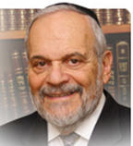

I think that we can all agree that it is difficult and challenging to part with one's wealth on behalf of an altruistic cause that will bring to the donor no immediate discernible physical profit or gain. Human beings are very possessive when it comes to money. Money and territorial rights are two main issues that have existed throughout the ages regarding disputes between individuals and even nations.

**A Great Burde4n on Our Teacher Moshe**

Heaven therefore placed a great burden on our teacher Moshe when it required him to ask the Jewish people to part with their wealth in large sums, to build a holy Tabernacle, the benefits of which the people could and would be measurable only in spiritual and eternal terms. In fact, the verse in the Torah regarding the necessity to contribute to the building of that Tabernacle can be understood as requiring that the donor, to fulfill that commandment, must donate part of one's own heart to this cause.

**Material Wealth is the Heart of Life**

For too many people, material wealth is really the heart of life and one does not part with it easily or joyfully. Though society generally disrespects and even abhors stinginess and miserly behavior in others, truth be said, within all of us lies the seeds of such behavior. Instinctively, humans want to retain what they think they already have, and they want to possess more of the world than they currently own or control.

We come into this world with clenched fists ready to grab everything that we can. Only at the very end, are our fists open, and our fingers fully extended to indicate that we really possess nothing of this physical world in which we have devoted so much of our time and efforts.

**The Importance of the Tabernacle**

There are many reasons advanced as to why the building of the Tabernacle should occupy such an important part in the biblical narrative of the Torah. One such idea is that the inherent difficulty to give awaywhat one has personally achieved is of such a nature that the Torah recorded for us the building of the Tabernacle in a long, detailed fashion. It is as though the Torah is emphasizing to us the difficulty involved in having to donate towards the construction of even the most glorious and noble of causes.

And, if it is difficult, as it certainly is, to give of one's own wealth towards a charitable cause, it is even more difficult to ask others to do so. The Talmud told us that the one that causes charitable causes to be financed and advanced by others through their donations, is greater even than the donor. We are all reluctant to ask others to part with their wealth no matter how noble the cause that we are representing. Therefore, the Torah reading of this week really speaks to us and to our continuing challenges as individuals and as a society.

*Reprinted from the current website of Rabbiwein.com*

**Parshas Trumah**

**The Mercy of HASHEM**

**By Rabbi Bentzion Shafier**

**Founder of TheSmuz.com**

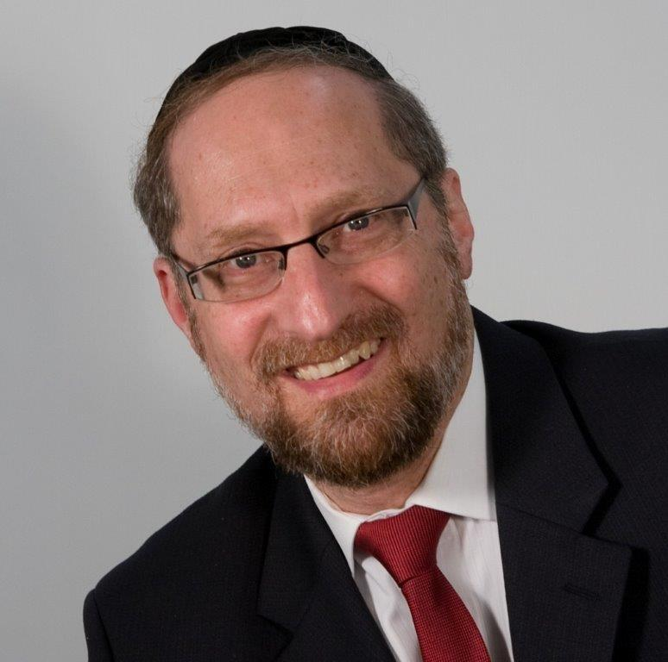

*“Speak to the Jewish People and they should take to Me, Trumah; from each man whose heart so motivates him, you should take my Trumah.”* Shemos 25:2

The entire Jewish nation, man, woman and child had experienced the revelation of HASHEM on Har Sinai. They saw HASHEM as clearly as a human can; and had attained a level of prophecy. Now, they were being offered one of the greatest gifts imaginable: HASHEM Himself was going to dwell amongst them. They would be allowed to relive that moment of glory on a daily basis.

Not only were they going to experience HASHEM’s presence regularly, they were being given the opportunity to participate in the building of the greatest edifice ever created—HASHEM’s dwelling place in this world. The gold, silver, and copper, the wood, hides and oil, should all come from the people themselves: “*from each man whose heart so motivates him*”.

It would come as no surprise that the zeal and enthusiasm with which the people offered donations to the Mishkan was impressive. In a short while, Moshe had to turn away any more donations, there was already more collected than could be used.

Interestingly, The Bal Ha’Turim explains that when HASHEM told Moshe to ask for contributions, He told him to ask in a gentle tone. Since it means that people will have to part with their money, please speak softly.

**It was all voluntary**

This Bal Ha’Turim is very difficult to understand, why would Moshe have to make this appeal in a gentle manner? This wasn’t a tax that the people were being forced to pay. It wasn’t some despot demanding an exorbitant bribe. This was a moment in history-- the Chosen Nation was being given this great opportunity to be a part of building the house of HASHEM, and they understood it for what it was. Why would Moshe have to speak softly? Surely they would give willingly.

**The Jews were fantastically rich**

The question becomes even more profound when we focus on the fact that when the Jewish People then were fabulously wealthy. HASHEM had promised Avrohom Avinu that when his children would leave bondage, it would be with great wealth. Right before the Jews left, they went to their Egyptian masters and “borrowed” gold, silver and all types of valuables-- they despoiled Mitzraim-- walking out with wealth that had been gathered for hundreds of years.

Now, they were being offered the chance to convert some of that great wealth into one of the greatest honors given to man- to become a builder of the Mishkan. This was a singular event in the history of mankind-- For eternity to be the one who provided the precious stones for the Ephod, or the one who contributed the gold for Menorah.

If every contribution was given willingly, the entire generation had enough to give, and it was a great honor to give, why would HASHEM be concerned that Moshe gently coax them into giving?

The answer to this question can be best understood when we focus on man’s relationship to his Creator.

**HASHEM’s relationship to man**

The Chovos Ha’Levovos explains that a concept that must be firmly embedded in the mind of a Jew is that HASHEM loves him. Even more, he says, a person has to firmly feel that HASHEM loves him more than he loves himself, and that HASHEM is more concerned for his good than he is.

In fact, the Chovos Ha’Levovos says that, if you could image the most merciful, generous, loving person that you have ever met, and then multiply that mercy by ten thousand, ten thousands, you won’t begin to fathom the love that HASHEM has for each of His creations.

This love can sometimes be seen in interesting manners. Many times Chazal tell us that HASHEM has mercy on the *money of Yisrael*. As if to say, HASHEM feels badly that the Jewish people have to spend money, even on things like Mitzvahs. Even though it is for their good, and even though it is the greatest investment that a person could make, yet it means their parting with things valuable to them, and if it could be, HASHEM feels badly. HASHEM is the Giver, always wishing to share of His good, to give more—not to take.

This seems to be the answer to the question on the Bal Ha’Turim: There is no question that it was the greatest honor to be given the chance to contribute something towards the Mishkan, and if their donation was accepted that mark of nobility would be something they would cherish for years. But it involved their giving. It meant they had to part with some of their wealth, and HASHEM, if it could be, felt badly.

It was as if HASHEM was saying: “Oy, it must be difficult. You have that precious gem, that beautiful gold. I feel badly, even asking.” Even though this person has taken something fleeting, and turned it into the greatest investment, at the moment that he had to give over those stones, on some level it was difficult, and HASHEM felt his pain. “Moshe, please speak with a soft voice.”

However, there is an additional layer here that brings this concept a step further. We live in a physical world, and are blind to the true value of things. But there will come a time when we will leave this heavy cloak of physicality, and see thing for what they truly were. At that moment, when we stand in the World of Truth we will recognize that every mitzvah was the greatest investment that we could have made- buying eternity with a fleeting currency of gold.

While we are unable to attain that clarity of thought now, HASHEM certainly see things that way. And what that means is that He stands there fully aware of the value of a mitzvah, and he recognizes that the best acquisition a person could make is to buy his World to Come in exchange for his money. But, since the person himself doesn’t see things that way now, HASHEM feels his pain, and is almost reluctant to ask.

**A Fantastic Illustration of Hashem’s Humility**

This is a fantastic illustration of the extent of HASHEM’s humility and concern for us, and the extent to which He is sensitive to our feelings. When a person focuses on the loving kindness that HASHEM showers upon us daily, we can grow in our apperception of that love, and then reciprocally, we can feel an overwhelming sense of appreciation and love to our Creator.

*Reprinted from the website of Theshmuz.com.*

**A Transformation of a “Regular” People into a Holy Nation**

**From the Talks of the Lubavitcher Rebbe**

**Rabbi Menachem Mendel Schneerson, Zt”l**

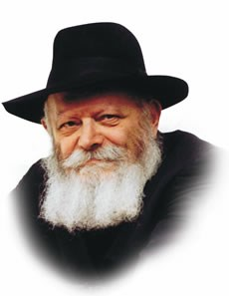

As we read in this week's Torah portion, Teruma, the commandment to erect a Sanctuary to G-d was given to the Jewish people as a whole -- men, women, and, as explained in the Midrash, even young children -- regardless of their stature or level of knowledge.

"All Jews," Maimonides wrote, "are obligated to build and support it...both physically and through contributions; men and women, as they were required in the desert."

Upon reflection, this is an astounding requirement, taking into consideration the significance of the Sanctuary and the function it performed.

The erection of the Sanctuary marked a truly unique innovation, the institution of a phenomenon that had never existed before. For the first time in history, G-d's Divine Presence would dwell in a physical structure. But how could such a thing be possible? Or, as the prophet phrased it, "The highest heavens cannot contain You; how can this house?" Our astonishment is even greater when one considers that even the simplest Jew was called upon to effect this.

Furthermore, we learn from the verse, "And they shall bring to Me a contribution," that the contributions to the Sanctuary had to be made with a pure intent, solely for the glory of G-d's name. This highest level of service of G-d, on which a person "does the truth because it is true," is not something which is attained by all; in fact, our Sages commented that "not every wise man can merit it." How then could G-d have expected this level of service from each and every individual, without exception?

The answer lies in the essential change that took place in the nature of the Jewish people when the Torah was revealed on Mount Sinai.

**G-d Transformed the Jews into a**

**Kingdom of Priesrs and a Holy Nation**

At Sinai, G-d took the Jews, a "regular" people like any other, and transformed them into "a kingdom of priests and a holy nation."

Forever after, every Jew would be connected to G-d by virtue of his "pintele Yid," the essential spark of Jewishness that can never be obliterated.

Since Sinai, no Jew can cut himself off from G-d, no matter how hard he/she may try. The inner desire of every Jew is to fulfill G-d's command; if this basic truth is not reflected in his outward behavior, it is only because he has allowed himself to be influenced by the Yetzer Horah (Evil Inclination).

Moreover, we are promised that "A person who serves G-d with an ulterior motive will eventually come to serve Him for the sake of His name." For, in truth, there are no ulterior motives, as the Jew's inner desire is solely to serve The Creator and carry out His will.

Thus every Jew, even the most untutored, has been given the power to build a Sanctuary in which G-d can dwell in the physical world. For the mere fact that he possesses a Jewish soul places him on the highest of all possible spiritual levels.

*Reprinted from the 5756/1996 edition of L’Chaim Weekly. Adapted from Likutei Sichot of the Rebbe Vol. 3*

**Rabbi Yisroel Reisman Highlights the Last**

**Great Jewish King**

**By Daniel Keren**

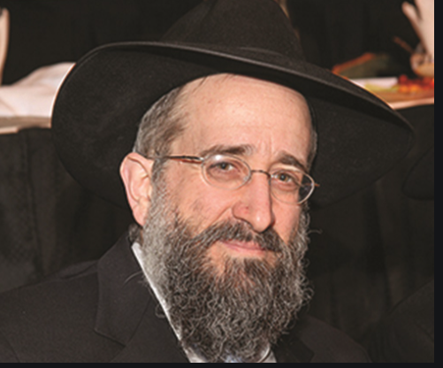

One featured speaker at last month’s Hakhel Yarchei Kallah Event on the legal holiday of Dr. Martin Luther King’s Birthday in Flatbush at the Agudath Israel of Madison was Rabbi Yisroel Reisman, mora d’asra of the host shul. He spoke on the topic of Yoshiyahu Hamelech, - “The Last Great Jewish King” from Chapters 34 and 35 of Sefer Divrei Hayomim Beis (the Second Book of Chronicles.)

Rabbi Reisman began by pointing out that Yoshiyahu Hamelech was not only the last great king in Klal Yisroel (the Jewish nation), but also the last hope that the downward spiral leading towards the destruction of the first Beis Hamikdosh [that had been built by King Solomon under the inspiration of his father King David] could be avoided. And with his untimely death that terrible tragedy of the Churban Bayis Rishon became inevitable.

Yoshiyahu was the great grandson of Chizkiyahu, the grandson of the wicked Menashe and the son of Amon who only ruled for two years. After Yoshiyahu’s death [by the invading Egyptian army], he was followed by three sons and a grandson who as kings of Yehuda were great disappointments.

**Began His Kingship at the Age of Eight Years Old**

In the beginning of Perek Lamed Daled, we learn that “Yoshiyahu was eight years old when he became king, and he reigned for 31 years in Yerushalayim. He did what was proper in the eyes of Hashem, following the ways of his forefather Dovid; he did not veer right or left. In his eighth year when he began to reign, while he was still a youngster, he began to seek out the G-d of his forefather David. In the twelfth year he bean to purge Yehudah and Yerushalayim of the high places and the asherah-trees, the idols and the molten images…”

Chazal, our Sages of blessed memory teach us that Yoshiyahu began at the age of eight when he became king to act as a dayan (religious judge) and based on his understanding of the Torah (Chumash), he would hear cases and give his psak (decision). However, all of the Sifrei Torah (Torah scrolls) with one exception had been corrupted by his wicked grandfather Menashe who promoted avoda zora (idol worship) and did not do that which was proper in the eyes of Hashem.

It happened only in the 18th year of Yoshiyahu’s reign that after purifying the land and the Temple that he sent Shaphan, Ma’aseiyahu and Yoach to reinforce and repair the Beis Hamikdosh which had fallen into great disrepair. “As they were removing the money that had been brought to the Temple of Hashem, Hilkiyahu the Kohen [Gadol] found the Book of the Torah of Hashem by Moshe and had it [the only uncorrupted Sefer Torah in all the Jewish nation] brought to Yoshiyahu Hamelech…

When the king read where the Sefer Torah was opened to, he read the horrifying words: “Hashem will lead you and your king to a nation you never knew.” He immediately rent his clothes in mourning and had the Kohen Gadol ask of Hulda the Prophetess the meaning of those words. It inspired him to launch a great teshuvah movement to get the nation to repent of their evil ways.

**The King Corrects His Mistaken Psakim**

Rabbi Reisman noted that Yoshiyahu Hamelech on the basis of the new uncorrupted Sefer Torah that had been rediscovered reexamined his previous psakim as a dayan and corrected those decisions which were mistaken and based on the corrupted Torah scrolls his grandfather had created.

Towards the end of Perek Lamed Daled, it is recorded that: “The king then stood at his place and sealed the Covenant before Hashem, to follow Hashem and to observe His commandments and His testimonies and His decrees with all his heart and with all his soul, to uphold the words of the Covenant written in this book.”

Rabbi Reisman said that in the aftermath of this unnerving discovery of the Sefer Toah, Yoshiyahu followed the example of his great grandfather [Chizkiyahu Hamelech] to utilize the korban Pesach (Passover offerings) in Yerushalayim to initiate a major teshuvah movement as recorded in the beginning of Chapter 35 of Divrei Hayomim Beis:

“Yoshiyahu made the Pesach-offering to Hashem in Yerushalayim…Such a Pesach-offering had not been celebrated since the days of Shmuel Hanavi (Samuel the Prophet). None of the kings of Israel performed like the Pesach-offering that Yoshiyahu did with the Kohanim, the Levites, all of Yehudah and Yisroel who were present, and the inhabitants of Yerushalayim. It was in the 18th year of Yoshiyahu’s reign that this Pesach-offering was performed.”

**The Importance of Pesach to the Kedushas Yisroel**

The significance of Pesach is that this is when the kedushas Yisrael (the holiness that comes as a result of the Bnei Yisroel (the Children of Israel) accepting the Torah at Har Sinai was affected. That is why both Chizkiyahu and Yoshiyahu utilized the holiday of Pesach to reignite the spirit of belonging of all Jews to being members of Klal Yisroel.

Towards the end of his life Yoshiyahu hid the Aron Habris [that contained the Luchas Habris, the Tablets that Moshe brought down on two occasions from Har Sinai.] Rabbi Reisman conjectured that it must have been a very difficult decision for Yoshiyahu to hide the Aron Habris, one of the most important symbols of the Jewish nation.

Despite Yoshiyahu’s great efforts towards turning the Jewish nation to a greater level of loyalty to Hashem, he must have had doubts about his potential for success in that endeavor. And rather that the Aron Habris be captured by an enemy force attacking the Beis Hamikdosh or destroyed in such an attack the king chose to hide it. Even when the Second Beis Hamikdosh was built, the Aron Habris was not returned to its exalted position.

The Rogatchover Gaon (Rabbi Yosef Rosen, 1858-1936) asked where does the Aron Habris have to be? You might think that it had been in the Kodesh Hakadoshim (the Holy of Holies) where the Kohan Gadol was allowed to enter only once a year on the holiest day of Yom Kippur.

**The Opinion of the Rogatchover Gaon**

Yet Rabbi Reisman explained that if you measured the parameters of the Kodesh Hakadoshim, you would realize that the Aron Habris cound not have possibly been inserted the Holy of Holies. Therefore the Rogatchover Gaon writes that it could be anywhere in the Beis Hamikdosh and if Yoshiyahu had buried it under the Har Habayis that too would work out.

Up until that time when Yoshiyahu had hidden the Aron Habris, Rabbi Reismajn said the halacha (Jewish law) had been determined by meticulous study of the Torah she Bichsav (the Written Torah). By commanding that the Aron Habris be hidden and telling the Leviim (the teachers of the Torah) to do their service, this was an allusion that from that time onwards the halacha would be determined by the careful study of the Torah she Baal Peh (the Oral Torah).

Rabbi Reisman offered a second opinion as to where the Aron Habris might been hidden, suggesting that it was hidden in the closet in the Beis Hamikdosh that was used to store the wood that would be burned for the offerings brought in the Beis Hamikdosh. The task of checking the wood to make sure that it was not infested with insects was given over to those Kohanim who suffered from physical blemishes that prohibited them from doing the regular priestly services in the holy Temple.

*Reprinted from the February 5, 2021 edition of The Flatbush Jewish Journal.*